**Assignment – 1 Start/Stop EC2 Instance using Lambda Function**

* **Screenshots**

**EC2 Instance id- i-0850e7bc6046ae9db**

**\* Stop the insatnce**

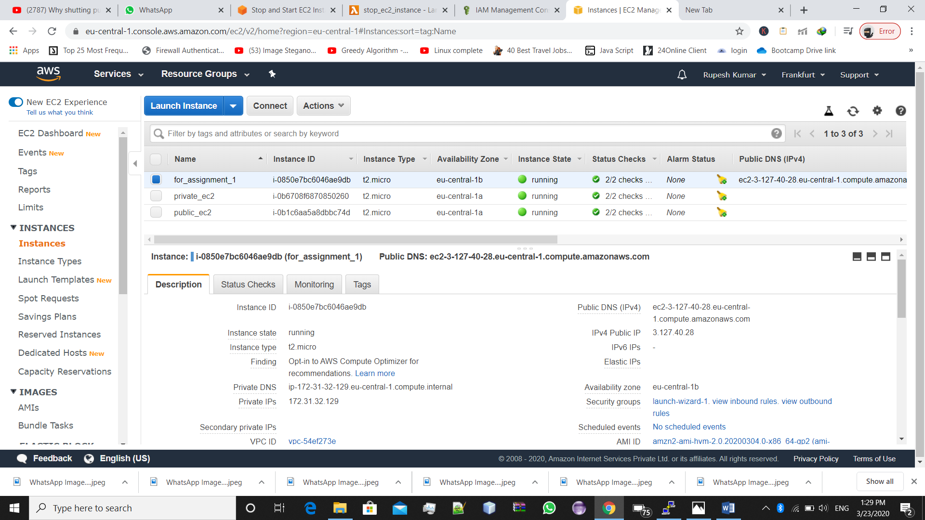->Instance in running state

->Lambda Function (code) for stopping the instance

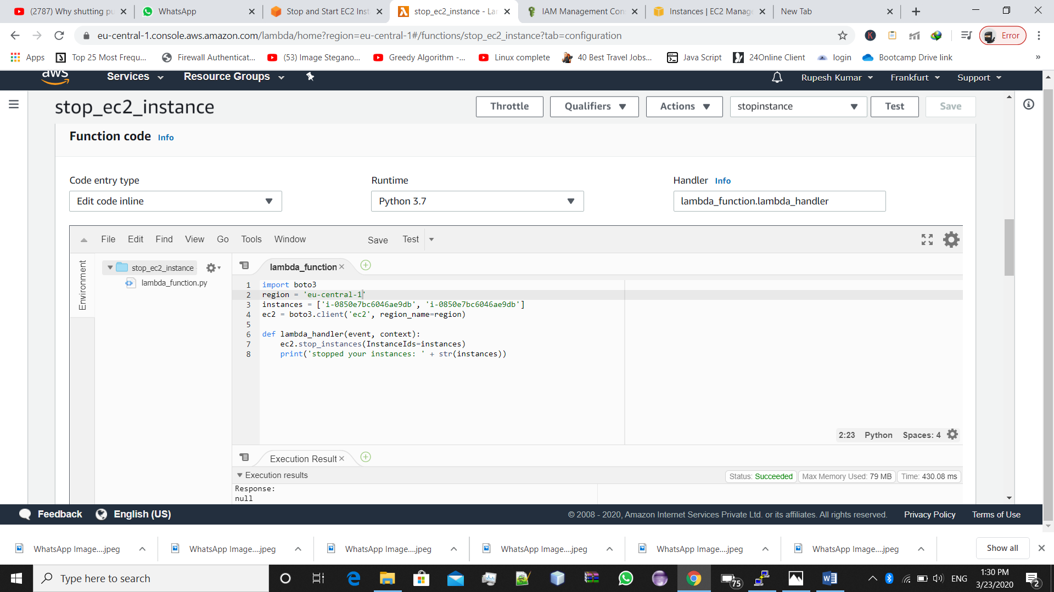

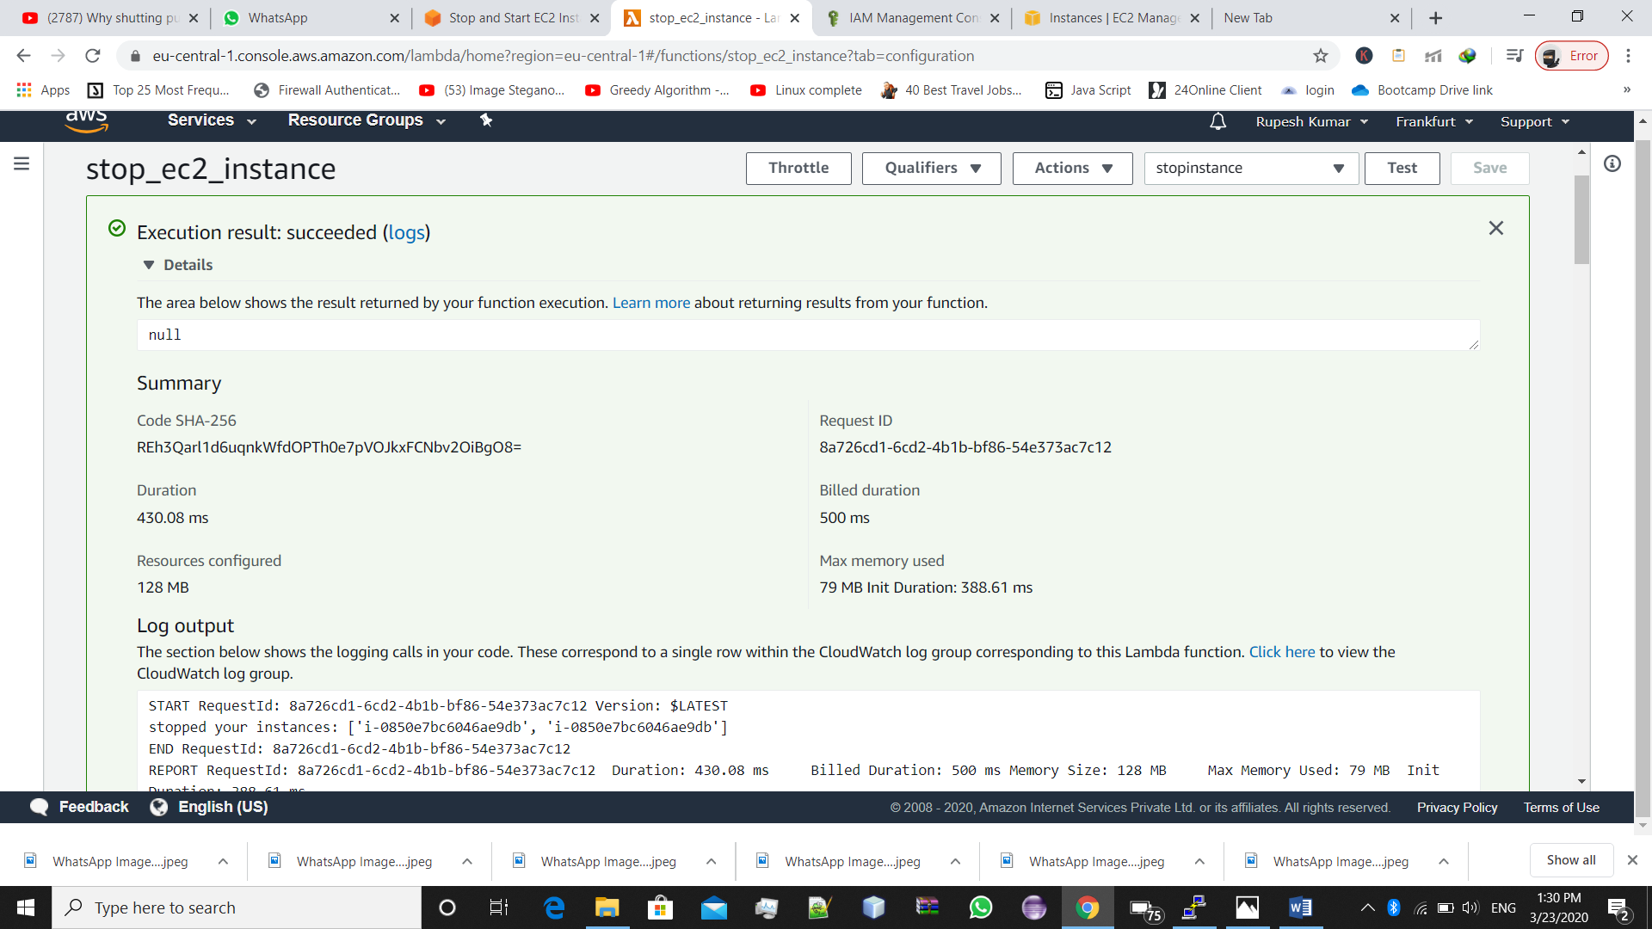->Lambda Function Execution Log

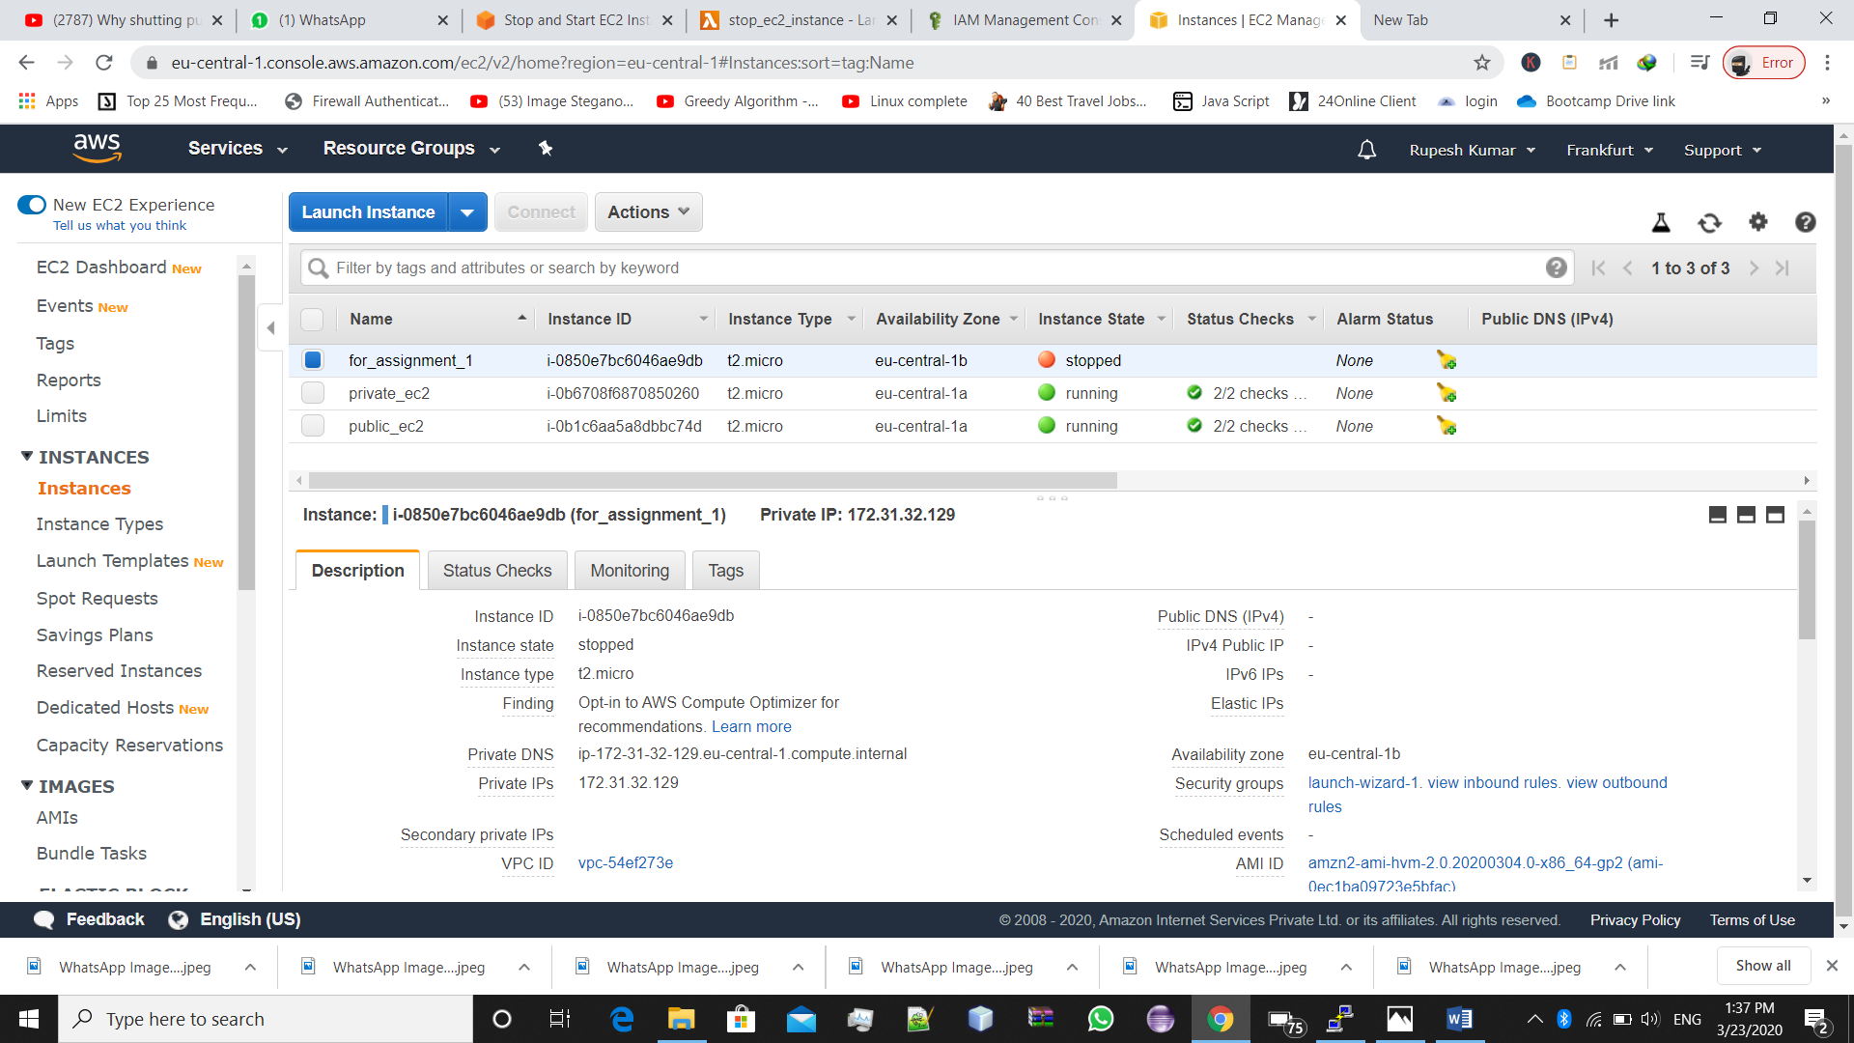->Instance Stopped

**\*Now, Start the Instance**

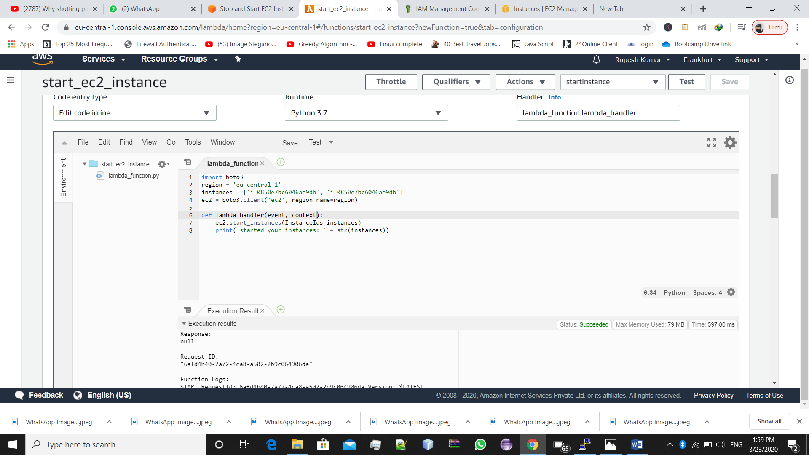-> Lambda Function (code) for starting the instance

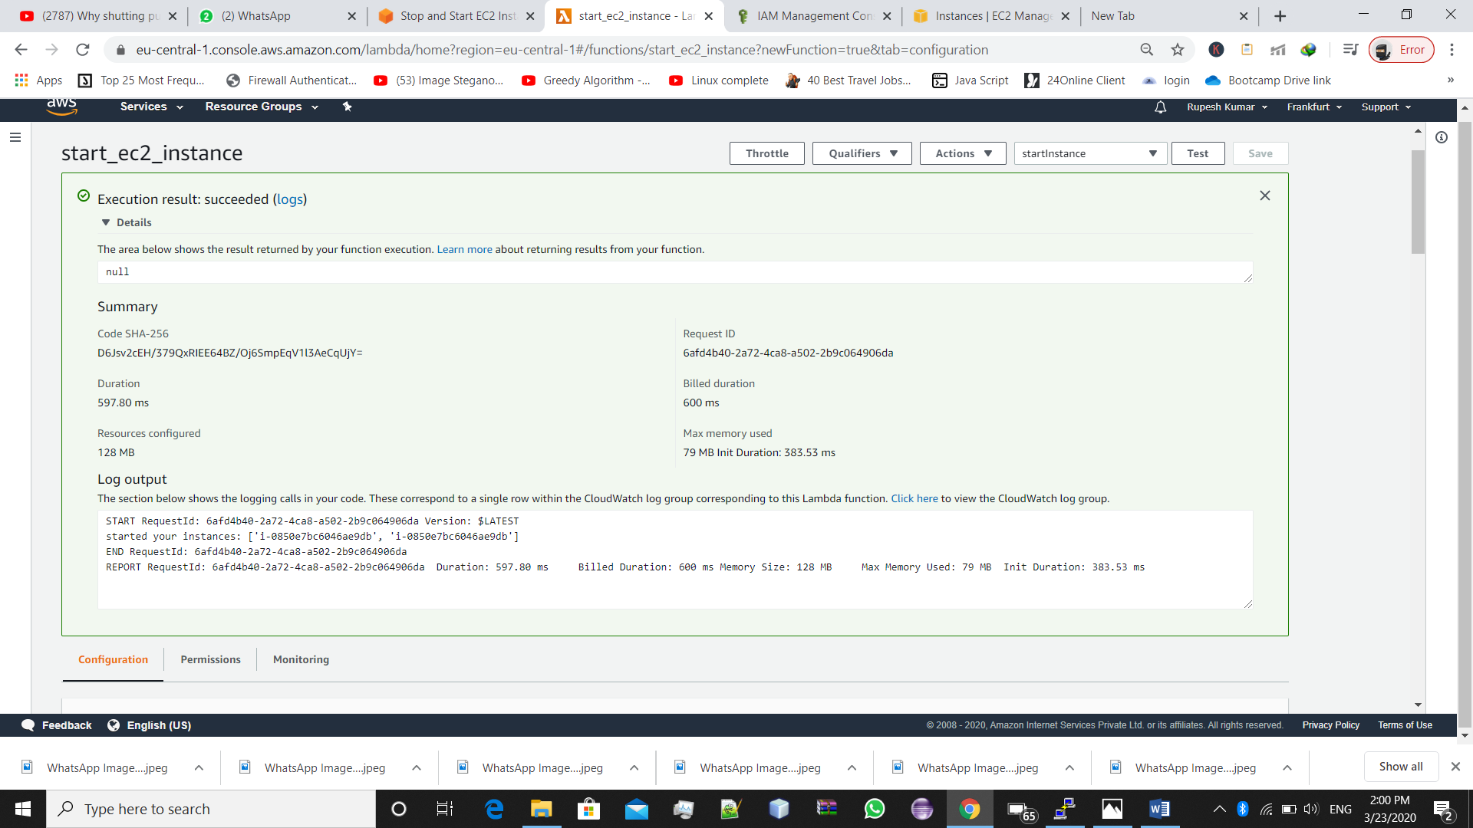-> Lambda Function Execution Log

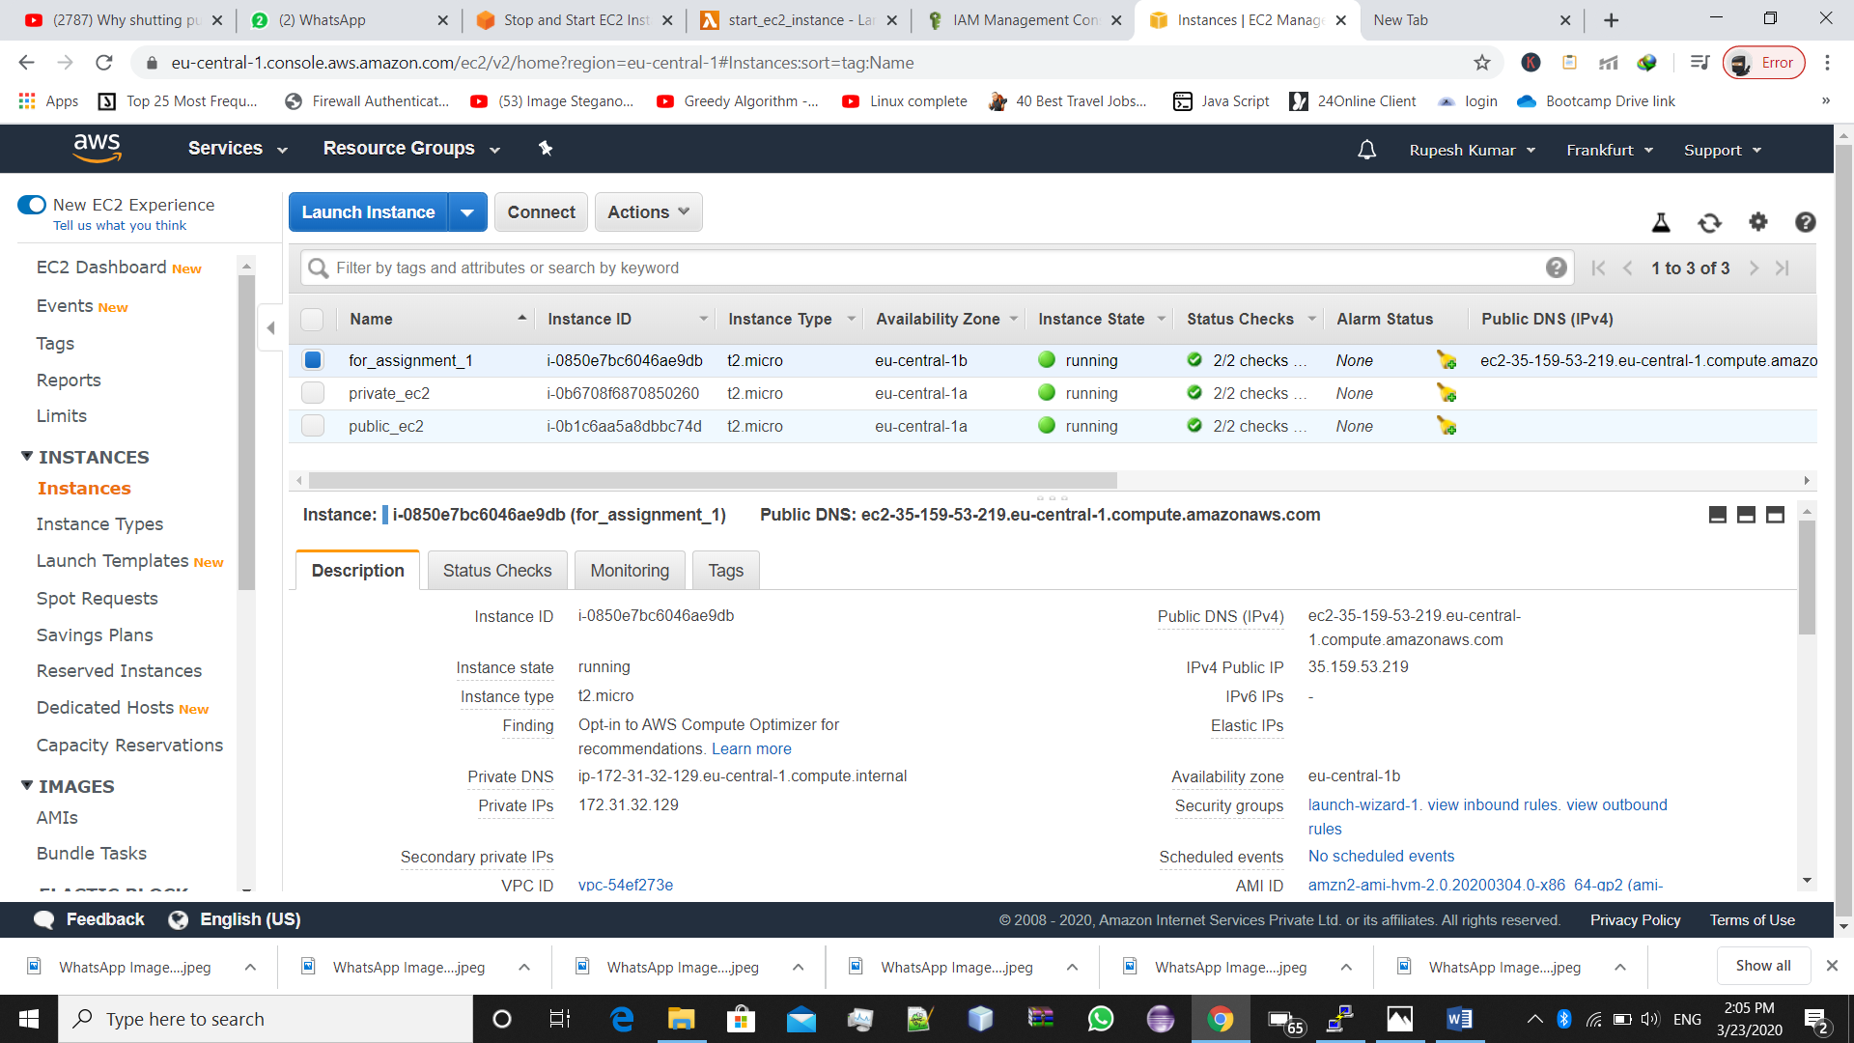->Instance Started